Haskell Set 7: Bindings, Cases, Beginning Recursion
1) Finish the following list comprehension using a let binding:
fromOrigin :: (RealFloat a) => (a, a) -> [a]
fromOrigin points = [ distance | ??????? ]

The function should take a list of tuples and generate the distance from the origin the tuple is and store
those in a list.
2) Finish the following list comprehension using a let binding:
closeEnough :: (RealFloat a) => (a, a) -> a -> [((a, a), a)]
closeEnough points d = ???
The function should take a list of tuples, calculate the distance they are from the origin, and keep only
the tuples whose distance are less than d. The final result should be a tuple, with the first part of the
tuple being the point itself and the second part of the tuple being the distance calculated.
3) Use a case expression to write a function which given a string returns "(a/an) ___". We will pretend
every word starting with a "aeiou" are 'an' words.
Ex: article apple -> "an apple"
article pear -> "a pear"
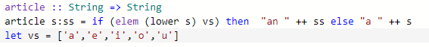
4) Use a case expression to write a function which given an integer and a string returns "You have (a/#)
___(no s or s)". We will pretend adding an s works for pluralazing all words.
Ex: haveNum 1 watermelon -> "You have a watermelon."
haveNum 2 apple -> "You have 2 apples."
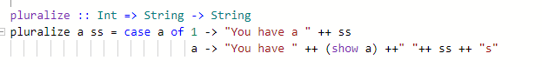

5) Use a case expression to write a function which given a letter grade writes "You earned a __ GPA."
A/a = 4.0, B/b = 3.0, C/c = 2.0, D/d = 1.0, F/f = 0.0
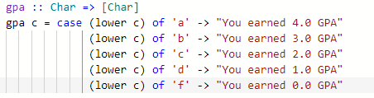6) Write a recursive function which calculates the factorial of any number.
factorial :: Num a => Num
| 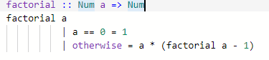

7) Write a recursive function which calculates a^n.
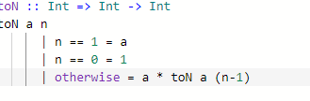
8) Write a recursive function that calculates any value in the Fibonacci sequence (0->0, 1->1, 2->1, 3->2,
4->3, ...)
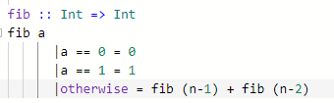
9) Write a recursive function that given a list builds the list backwards.

